_{NIKE SKLS NFS}
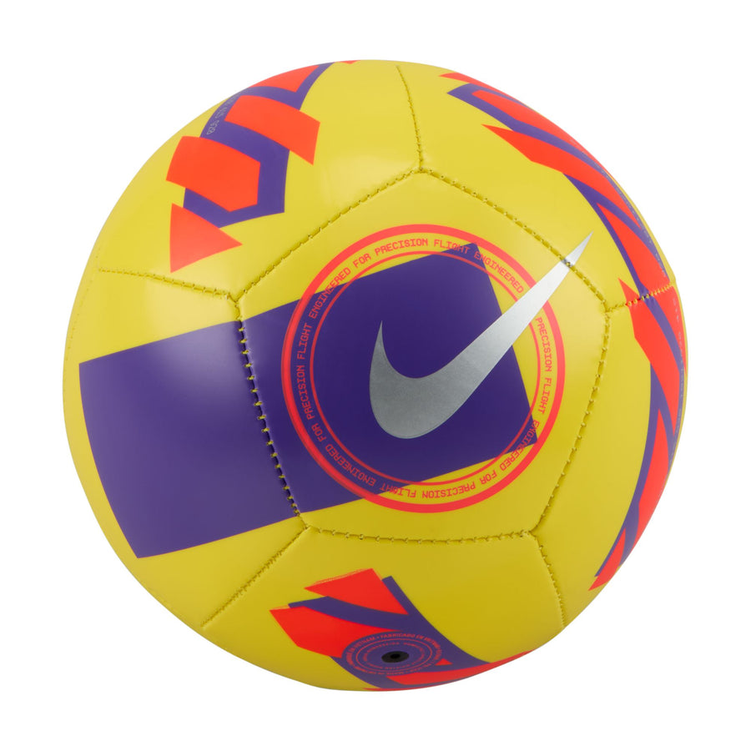
PRICE: Approximately Rs. 5,999

_{Introduction:}
The Nike SKLS NFS is a performance-focused training product designed to enhance skill development and everyday practice. Built with durability and precision in mind, this product supports consistent use during training sessions while maintaining reliable performance. Its practical design makes it suitable for athletes who want dependable equipment that delivers control, balance, and long-lasting quality. Whether used for regular drills or casual practice, the Nike SKLS NFS reflects Nike’s commitment to functional sports gear that helps users improve with confidence.
Product Overview:
The Nike SKLS NFS is designed for training and practice, offering a balanced structure that supports controlled movement and consistent performance. It is suitable for repeated use and maintains its form even during intense sessions.
About the Brand:
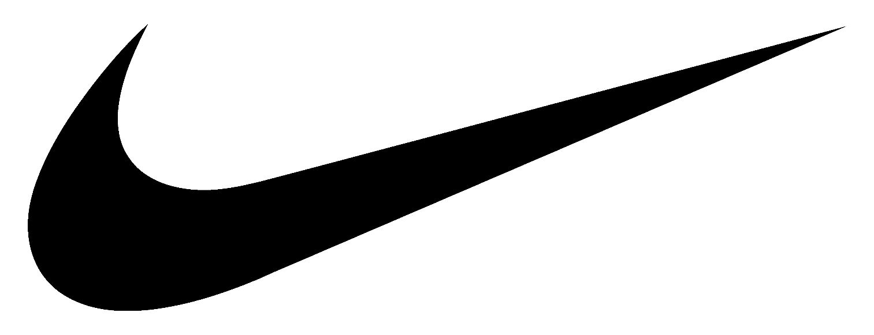
Nike is a world-leading sportswear brand known for innovation, performance, and iconic design. With decades of experience in athletic footwear and apparel, Nike continues to set global standards in comfort, durability, and style for athletes and lifestyle users alike.

Key Features:
- Designed for training and skill development
- Balanced construction for consistent performance
- Durable build suitable for regular use
- Reliable shape retention
- Clean, minimal Nike branding

Design & Build Quality:
The Nike SKLS NFS features a simple yet functional design focused on performance rather than excess styling. Its solid construction ensures stability and reliability during use, while quality finishing reflects Nike’s attention to detail and product standards.
Storage & Capacity:
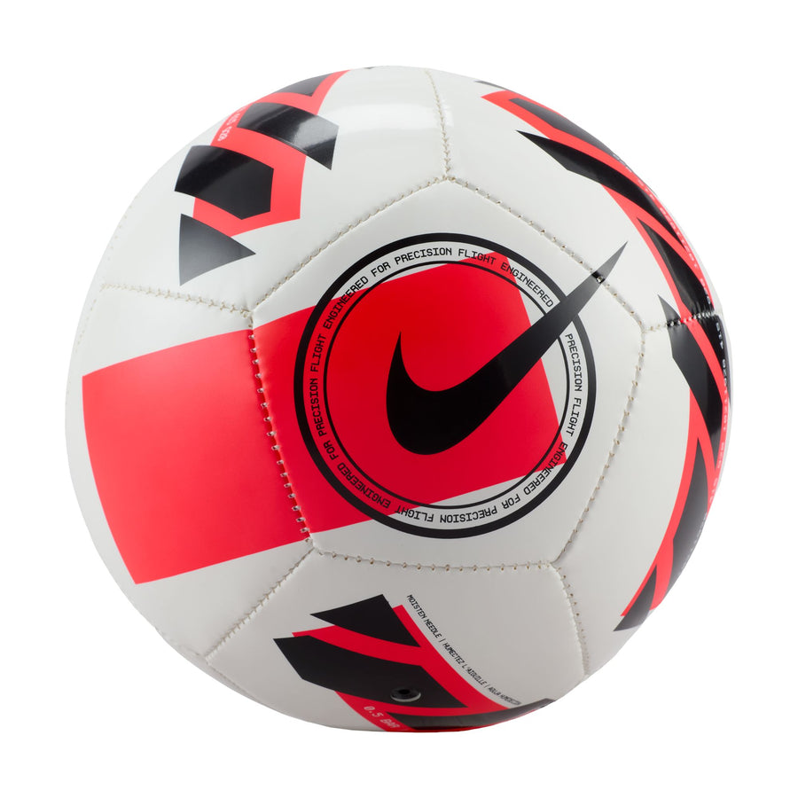
The product is easy to store and transport due to its practical size and lightweight nature. It fits conveniently in sports bags and training kits, making it suitable for daily practice and travel.

Material & Durability:
Constructed using durable materials, the Nike SKLS NFS is built to withstand frequent training sessions. Its strong outer structure helps resist wear, ensuring long-term usability while maintaining performance consistency.
Ideal For:
- Training and practice sessions
- Skill development drills
- Athletes and sports learners
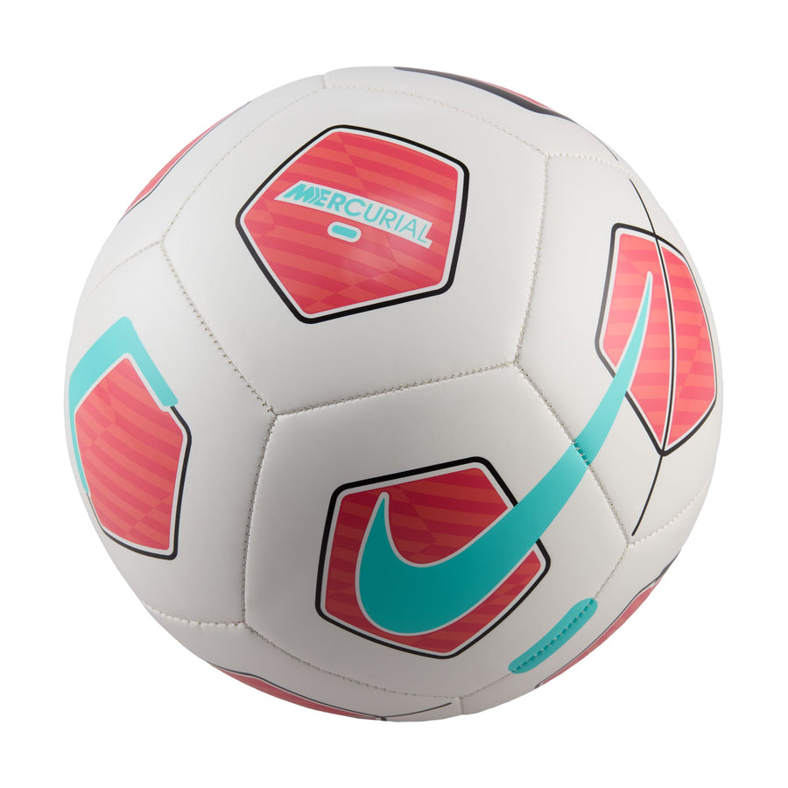
- Regular indoor or outdoor use

Care Instructions:
- Clean with a soft, damp cloth
- Avoid exposure to sharp surfaces
- Store in a dry place when not in use
- Do not use harsh cleaning chemicals
Product Specifications:
- Brand: Nike
- Model: SKLS NFS
- Product Type: Training Equipment
- Usage: Practice and skill training
- Build: Durable construction
- Design: Performance-focused
- Branding: Nike logo

Product Summary:
The Nike SKLS NFS is a dependable training product designed for athletes who value durability and consistent performance. With its practical design and trusted Nike quality, it serves as a reliable choice for improving skills and supporting regular training routines.

